Les05B-Index-Sequence 20202

Was in Chapter 11(in Oracle notes)



**Objectives**

After completing this lesson, you should be able to do the following:

• Create simple and complex views

2020 summer

Only covering Sequences and indexes. The res was deleted.

• Retrieve data from views

• Create, maintain, and use sequences

• Create and maintain indexes

• Create private and public synonyms – maybe

SEQUENCE

11-23

# Overview of sequences:

– Creating, using, and modifying a sequence

– Cache sequence values

– NEXTVAL and CURRVAL pseudo columns

**A sequence is a database object that creates integer values.**

You can create sequences and then use them to **generate numbers**.

- Automatic number like order numbers

A sequence:

• Can automatically generate unique numbers

• Is a shareable object – probably would not see this

• Can be used to create a primary key value

• Replaces application code

• Speeds up the efficiency of accessing sequence values

- When cached in memory

CREATE SEQUENCE Statement

Generic syntax

**CREATE SEQUENCE *sequence ß name of sequence***

**[INCREMENT BY *n*] ß specifies increment value**

**[START WITH *n*] ß Starting (default 1 if omitted**

**[{MAXVALUE *n* | NOMAXVALUE}] ß maximum value – default is nomax**

**[{MINVALUE *n* | NOMINVALUE}] ß this is default if not stated**

**[{CYCLE | NOCYCLE}] ß allows recycling of numbers–reuse**

**[{CACHE *n* | NOCACHE}]; ß allows caching x values-faster**

* Never use CYCLE if using it to generate Primary Keys

Here is a sequence to use as PK

**CREATE SEQUENCE dept_deptid_seq – note naming**

**INCREMENT BY 10**

**START WITH 120**

**MAXVALUE 9999**

**NOCACHE**

**NOCYCLE;**

NEXTVAL and CURRVAL Pseudo columns

• NEXTVAL

- used to extract successive sequence number

- returns the next available sequence value.

It returns a unique value every time it is referenced, even for different users.

Specify NEXTVAL and the sequence name

• CURRVAL obtains the current sequence value.

• NEXTVAL must be issued for that sequence before CURRVAL contains a value.

SEE EXAMPLES

Using a Sequence

**INSERT INTO departments**

**(department_id, department_name, location_id)**

**VALUES (dept_deptid_seq.NEXTVAL, 'Support', 2500);**

View current value of sequence

**SELECT dept_deptid_seq.CURRVAL**

**FROM dual;**

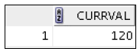

**C**aching Sequence Values

• Caching sequence values in memory gives faster access to those values.

- Less going out to disk to retrieve the latest number and update it

• Gaps in sequence values can occur when:

Often an exam question

– A rollback occurs

– The system crashes

– A sequence is used in another table (rare)

**\* What is in cache is lost**

Modifying a Sequence

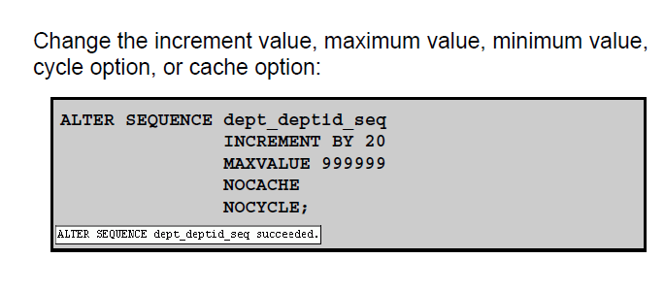

Guidelines:

- You must be the owner or have the ALTER privilege for the sequence.

- Only *future sequence* numbers are affected.

- The sequence must be dropped and re-created to restart the sequence at a different number.

- Some validation is performed.

- To remove a sequence, use the DROP statement:

DROP SEQUENCE

**DROP SEQUENCE**  **dept_deptid_seq;**

INDEX

**Is used by the Oracle server to speed up the retrieval of rows by using a pointer.**

If you do not have an index on the column then a FULL table scan is required.

**Can reduce I/O**

The purpose of an index is to reduce I/O in accessing required data from disk

**Independent of the table**

By being independent of the underlying table the index can be dropped or created with no effect on the data in the table or other indexes.

NOTE: Dropping a table will also drop any corresponding indexes.

**Maintained automatically by Oracle Server**

No programmer or user activity is required to maintain the index once it is created.

DBA usually creates and decides on index

# Which columns to index?

EXAMPLE:

Consider EMPLOYEE table

Would you index last name YES

job_id not likely as it repeats a lot

email maybe – don't know

Depends on if it is searched a lot

salary only if use it as a search condition a lot

Create and DROP index

**How Are Indexes Created?**

Automatically:

A unique index is created automatically when you define a

- PRIMARY KEY or

- UNIQUE constraint in a table definition.

Oracle handles the indexing on primary and unique constraints

Manually:

Developers can create nonunique indexes on other columns to speed up access to rows.

CREATE INDEX

**CREATE INDEX emp_last_name_idx -- note naming convention**

**ON employees (last_name);**

GUIDELINES:

Last name

Gets to values quicker

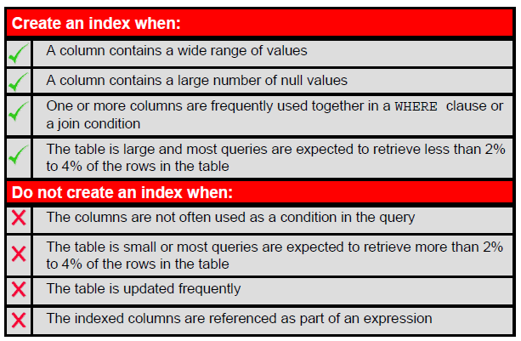

**SOME RULES ON INDEXES**

##### **1 The column is used often in a where clause and the table is large.**

Example 1:

In the lost or stolen credit card department, many callers do not have the credit card number handy. The company uses the name to seek your information. With millions of credit card users an index would be faster.

Example 2:

A customer phones to place an order for product. The customer number is your company’s reference number and often is unknown to the caller. Again a search by name is often used.

##### **2 The table is very large and most retrievals display a small amount of data.**

The above example and reporting/queries that retrieve 1 to 5% of the data.

###### **TRADE-OFF**

More indices do not speed the processing overall.

-- For every index there is overhead activities to maintain the index.

Null values are not included in the index

REMOVE INDEX

**DROP INDEX emp_last_name_idx;**

**Cannot be modified**

**Must drop and add**

Must be owner to be able to DROP

Or have privilege

What happens to the data - NOTHING

What happens to an application - NOTHING – may run slower

What is effected – just the speed of searches

DROP SEQUENCE -- Data not effected

-- Code might be if it uses the sequence

Code never has an index in it

NOTE:

Drop a table, indexes and sequence automatically dropped

Views remain

Investigate: Applying 2 indices on Last name and first name. Several methods.